|  |  |
| --- | --- |
| TANGUB CITY GLOBAL COLLEGE  J. Luna St., Maloro, Tangub City, Misamis Occidental    **INSTITUTE OF COMPUTER STUDIES**  **1st Semester, Academic Year 2024-2025** | |
| Student ID No.: 214527 | Name: Joevie P. Duhaylungsod |
| Schedule: 12:00 – 1:00 (MW) | Date: 20/11/2024 Score: |

**WEBINAR SUMMARY REPORT**

**Webinar 4: Digital Tools for Classroom Engagement**

**Date: September 4, 2:00 pm to 4:00 pm**

**Executive Summary**

The webinar, " **Digital Tools for Classroom Engagement** " led by Ronald Piper R. Ramboanga, RN, MA founder and Owner, Knights of online markets. Digital tools are reshaping classrooms by making learning more interactive, personalized, and fun. Platforms like Kahoot and Google Classroom spark curiosity, encourage collaboration, and cater to different learning styles. Gamified activities boost motivation, while tools like Microsoft Teams make teamwork easy and engaging.

**Discussion**

Mr. Ronald Piper R. Ramboanga, RN, MA began by addressing the rise in Digital tools have transformed classrooms by making learning interactive, engaging, and collaborative. Platforms like participation through fun activities, while tools like Google Docs and enable real-time collaboration. Creative platforms like Canva and Flipgrid let students visually and expressively present ideas, and VR/AR tools like Google Expeditions make concepts immersive and tangible. Despite challenges like accessibility and potential distractions, these tools, when integrated thoughtfully, create inclusive, dynamic learning environments that prepare students for the future.

**Concluding Remarks**

The session Digital tools have revolutionized classroom engagement, making learning more interactive, inclusive, and exciting. They empower teachers to connect with diverse learners and prepare students for a tech-driven world. However, their success lies in thoughtful use, ensuring access for all, and balancing innovation with human connection. When used wisely, these tools inspire curiosity and collaboration, shaping classrooms where students thrive.

**CERTIFICATION:**

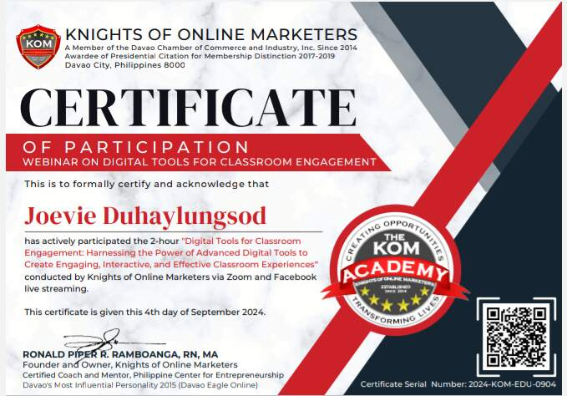

**REGISTRATION:**

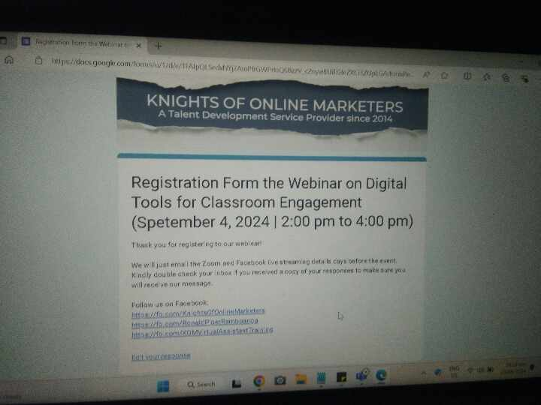

**ATTENDANCE AND EVALUATION:**